**Report**

1.Target Selection:

Bounty Cams 1

Credentials:

IP: 195.60.68.241

HTTPS: root / 9abbc9958d1700af6e6ecbcf3446b560807f2b1cedb5cd62f44dc3ca2426253c

SSH: root / 9abbc9958d1700af6e6ecbcf3446b560807f2b1cedb5cd62f44dc3ca2426253c

2.Required Tools:

Install these tools

bash

sudo apt update && sudo apt install -y

* nmap
* nikto
* whatweb
* gobuster
* wappalyzer
* shodan

3.Full Testing Commands:

Phase 1:

**Reconnaissance:** Conduct passive and active information gathering.

Focus on:

* Subdomain enumeration
* CMS detection
* Directory brute-forcing
* Banner grabbing
* SSL certificate inspection
* Public leak searches

Phase 2:

**Vulnerability Assessment:** Attempt to identify any potential security weaknesses

such as:

* Directory Listing
* Open ports or unnecessary services
* Information disclosure
* Broken access controls (without exploiting)
* This report is generated by NMAP TOOL (scan_results.txt)

**Command used** : nmap -sS -sV -p- -T4 --script vuln,default,safe -oN scan_results.txt 195.60.68.241

**Command Components Explained:**

1. **nmap**
   * The network scanning tool itself.
2. **-sS** (Stealth SYN Scan)
   * **TCP SYN Scan**: Sends SYN packets to check for open ports without completing the TCP handshake.
   * **Advantage**: Fast and less likely to be logged by firewalls compared to full TCP connects (-sT).
3. **-sV** (Version Detection)
   * Probes open ports to determine **service/version info**.
   * Helps identify outdated software with known vulnerabilities.
4. **-p-** (Scan All Ports)
   * Scans **all 65,535 TCP ports**.
   * Ensures no services are missed.
5. **-T4** (Timing Template)
   * Aggressive speed setting (4 out of 5). Balances speed and reliability.
   * Faster scans but may risk being detected or overwhelming the target.
6. **--script vuln,default,safe** (NSE Scripts)
   * **vuln**: Runs vulnerability detection scripts .
   * **default**: Default scripts .
   * **safe**: Non-intrusive scripts (avoids crashing services).
7. **-oN scan_results.txt** (Output)
   * Saves results to **scan_results.txt** in normal human-readable format.
8. **195.60.68.241**
   * The target IP address .

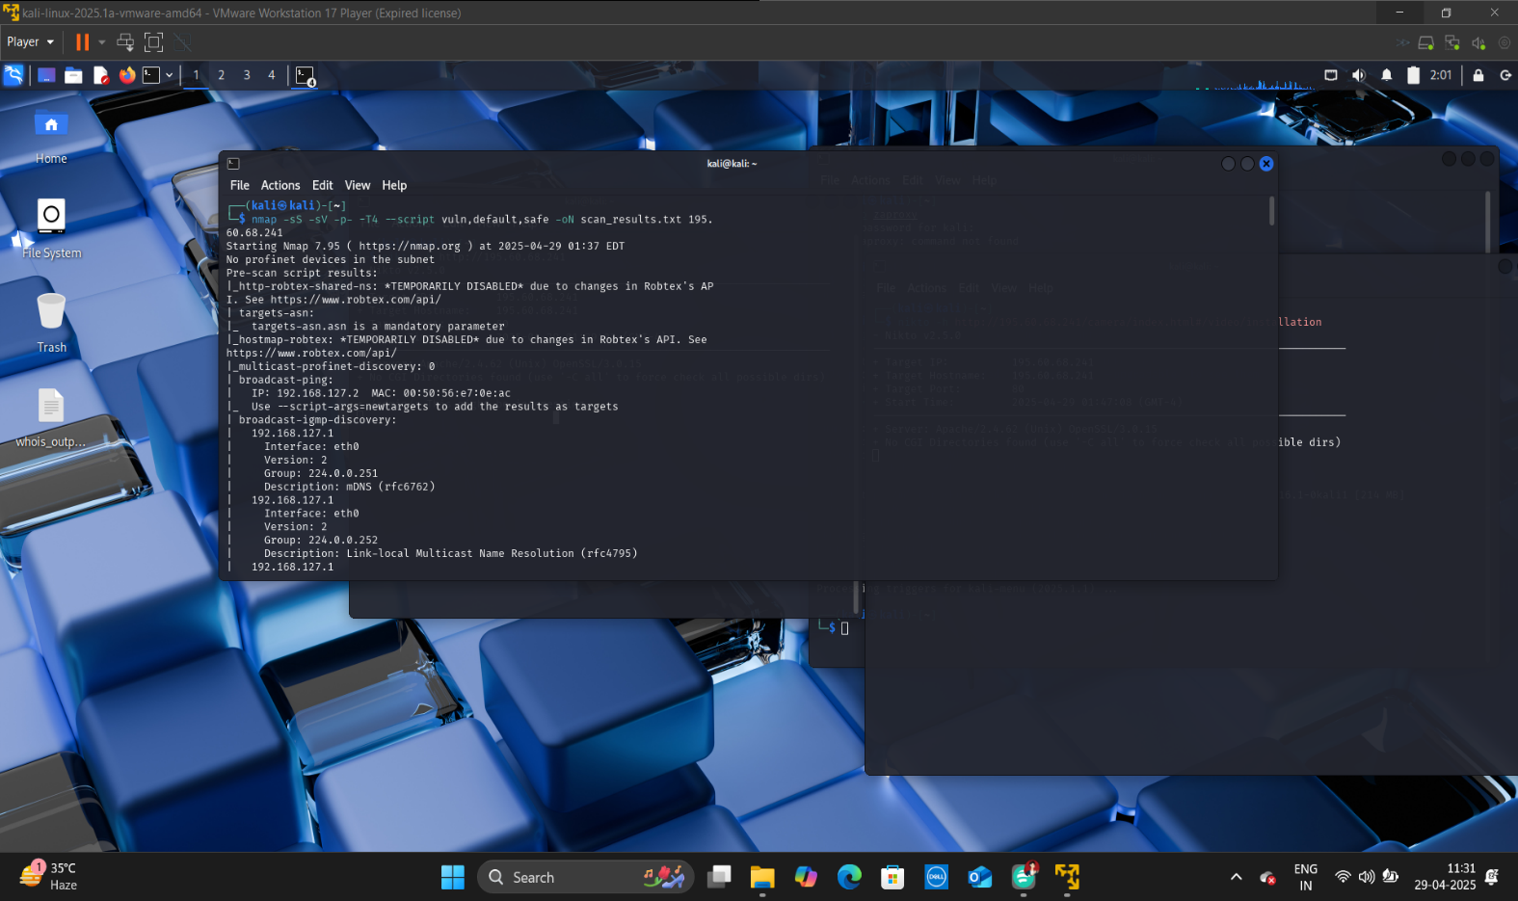

# Nmap 7.95 scan initiated Tue Apr 29 01:37:10 2025 as: /usr/lib/nmap/nmap --privileged -sS -sV -p- -T4 --script vuln,default,safe -oN scan_results.txt 195.60.68.241

Pre-scan script results:

|_http-robtex-shared-ns: *TEMPORARILY DISABLED* due to changes in Robtex's API. See https://www.robtex.com/api/

| targets-asn:

|_ targets-asn.asn is a mandatory parameter

|_hostmap-robtex: *TEMPORARILY DISABLED* due to changes in Robtex's API. See https://www.robtex.com/api/

|_multicast-profinet-discovery: 0

| broadcast-ping:

| IP: 192.168.127.2 MAC: 00:50:56:e7:0e:ac

|_ Use --script-args=newtargets to add the results as targets

| broadcast-igmp-discovery:

| 192.168.127.1

| Interface: eth0

| Version: 2

| Group: 224.0.0.251

| Description: mDNS (rfc6762)

| 192.168.127.1

| Interface: eth0

| Version: 2

| Group: 224.0.0.252

| Description: Link-local Multicast Name Resolution (rfc4795)

| 192.168.127.1

| Interface: eth0

| Version: 2

| Group: 239.255.102.18

| Description: Organization-Local Scope (rfc2365)

| 192.168.127.1

| Interface: eth0

| Version: 2

| Group: 239.255.255.250

| Description: Organization-Local Scope (rfc2365)

|_ Use the newtargets script-arg to add the results as targets

| broadcast-dhcp-discover:

| Response 1 of 1:

| Interface: eth0

| IP Offered: 192.168.127.140

| Server Identifier: 192.168.127.254

| Subnet Mask: 255.255.255.0

| Router: 192.168.127.2

| Domain Name Server: 192.168.127.2

| Domain Name: localdomain

| Broadcast Address: 192.168.127.255

|_ NetBIOS Name Server: 192.168.127.2

| broadcast-listener:

| ether

| ARP Request

| sender ip sender mac target ip

| 192.168.127.2 00:50:56:e7:0e:ac 192.168.127.140

| udp

| DHCP

| srv ip cli ip mask gw dns vendor

|_ 192.168.127.254 192.168.127.140 255.255.255.0 192.168.127.2 192.168.127.2 -

|_eap-info: please specify an interface with -e

Nmap scan report for 195.60.68.241

Host is up (0.00079s latency).

Not shown: 65531 filtered tcp ports (no-response)

PORT STATE SERVICE VERSION

22/tcp open ssh OpenSSH 9.8 (protocol 2.0)

|_banner: SSH-2.0-OpenSSH_9.8

| vulners:

| cpe:/a:openbsd:openssh:9.8:

| PACKETSTORM:189283 6.8 https://vulners.com/packetstorm/PACKETSTORM:189283 *EXPLOIT*

| F79E574D-30C8-5C52-A801-66FFA0610BAA 6.8 https://vulners.com/githubexploit/F79E574D-30C8-5C52-A801-66FFA0610BAA *EXPLOIT*

| CVE-2025-26465 6.8 https://vulners.com/cve/CVE-2025-26465

| 1337DAY-ID-39918 6.8 https://vulners.com/zdt/1337DAY-ID-39918 *EXPLOIT*

| CVE-2025-26466 5.9 https://vulners.com/cve/CVE-2025-26466

|_ CE606E2D-D0A5-5DE8-8A61-E7AB65789A99 5.9 https://vulners.com/githubexploit/CE606E2D-D0A5-5DE8-8A61-E7AB65789A99 *EXPLOIT*

| ssh2-enum-algos:

| kex_algorithms: (5)

| server_host_key_algorithms: (1)

| encryption_algorithms: (6)

| mac_algorithms: (10)

|_ compression_algorithms: (2)

| ssh-hostkey:

|_ 256 16:0d:da:de:5f:8b:84:7e:15:39:1d:8c:d6:a1:f5:50 (ECDSA)

80/tcp open http Apache httpd 2.4.62 ((Unix) OpenSSL/3.0.15)

|_http-date: Mon, 28 Apr 2025 17:49:46 GMT; -11h58m33s from local time.

| http-headers:

| Date: Mon, 28 Apr 2025 17:49:49 GMT

| Server: Apache/2.4.62 (Unix) OpenSSL/3.0.15

| X-Content-Type-Options: nosniff

| X-Frame-Options: SAMEORIGIN

| X-XSS-Protection: 1; mode=block

| Content-Security-Policy: default-src 'self'; frame-ancestors 'self'; connect-src 'self' https://*.google-analytics.com https://*.analytics.google.com https://*.googletagmanager.com https://*.axis.com mediastream: blob:; script-src 'self' https://*.googletagmanager.com https://www.google-analytics.com https://ssl.google-analytics.com https://*.axis.com; style-src 'self' 'unsafe-inline'; img-src 'self' https://*.google-analytics.com https://*.googletagmanager.com https://*.axis.com data: blob:; media-src 'self' mediastream: blob:; object-src 'none'

| Referrer-Policy: strict-origin-when-cross-origin

| Upgrade: h2

| Connection: Upgrade, close

| Last-Modified: Tue, 05 Apr 2011 23:00:00 GMT

| Accept-Ranges: bytes

| Content-Length: 173

| Cache-Control: max-age=0, no-cache, no-store, must-revalidate

| Pragma: no-cache

| Content-Type: text/html

|

|_ (Request type: HEAD)

|_http-mobileversion-checker: No mobile version detected.

| http-security-headers:

| X_Frame_Options:

| Header: X-Frame-Options: SAMEORIGIN

| Description: The browser must not display this content in any frame from a page of different origin than the content itself.

| X_XSS_Protection:

| Header: X-XSS-Protection: 1; mode=block

| Description: The browser will prevent the rendering of the page when XSS is detected.

| X_Content_Type_Options:

| Header: X-Content-Type-Options: nosniff

| Description: Will prevent the browser from MIME-sniffing a response away from the declared content-type.

| Content_Security_Policy:

| Header: Content-Security-Policy: default-src 'self'; frame-ancestors 'self'; connect-src 'self' https://*.google-analytics.com https://*.analytics.google.com https://*.googletagmanager.com https://*.axis.com mediastream: blob:; script-src 'self' https://*.googletagmanager.com https://www.google-analytics.com https://ssl.google-analytics.com https://*.axis.com; style-src 'self' 'unsafe-inline'; img-src 'self' https://*.google-analytics.com https://*.googletagmanager.com https://*.axis.com data: blob:; media-src 'self' mediastream: blob:; object-src 'none'

| Description: Define loading policy for all resources type in case of a resource type dedicated directive is not defined (fallback).

| Description: Define which scripts the protected resource can execute.

| Description: Define from where the protected resource can load plugins.

| Description: Define which styles (CSS) the user applies to the protected resource.

| Description: Define from where the protected resource can load images.

| Description: Define from where the protected resource can load video and audio.

| Description: Define from where the protected resource can be embedded in frames.

| Description: Define which URIs the protected resource can load using script interfaces.

| Cache_Control:

| Header: Cache-Control: max-age=0, no-cache, no-store, must-revalidate

| Pragma:

|_ Header: Pragma: no-cache

|_http-title: Site doesn't have a title (text/html).

|_http-dombased-xss: Couldn't find any DOM based XSS.

|_http-csrf: Couldn't find any CSRF vulnerabilities.

|_http-referer-checker: Couldn't find any cross-domain scripts.

|_http-server-header: Apache/2.4.62 (Unix) OpenSSL/3.0.15

|_http-stored-xss: Couldn't find any stored XSS vulnerabilities.

|_http-fetch: Please enter the complete path of the directory to save data in.

|_http-xssed: No previously reported XSS vuln.

| http-useragent-tester:

| Status for browser useragent: 200

| Allowed User Agents:

| Mozilla/5.0 (compatible; Nmap Scripting Engine; https://nmap.org/book/nse.html)

| libwww

| lwp-trivial

| libcurl-agent/1.0

| PHP/

| Python-urllib/2.5

| GT::WWW

| Snoopy

| MFC_Tear_Sample

| HTTP::Lite

| PHPCrawl

| Zend_Http_Client

| http client

| PECL::HTTP

| Wget/1.13.4 (linux-gnu)

|_ WWW-Mechanize/1.34

|_http-comments-displayer: Couldn't find any comments.

| http-enum:

| /admin/: Possible admin folder

| /admin/admin/: Possible admin folder

| /admin/index.html: Possible admin folder

| /config/public/usergrp.gif: AXIS StorPoint (401 Unauthorized)

| /config/: Potentially interesting folder (401 Unauthorized)

|_ /view/: Potentially interesting folder

443/tcp open ssl/http Apache httpd 2.4.62 ((Unix) OpenSSL/3.0.15)

|_http-csrf: Couldn't find any CSRF vulnerabilities.

|_http-fetch: Please enter the complete path of the directory to save data in.

|_http-stored-xss: Couldn't find any stored XSS vulnerabilities.

|_http-server-header: Apache/2.4.62 (Unix) OpenSSL/3.0.15

|_http-title: 400 Bad Request

|_http-mobileversion-checker: No mobile version detected.

|_http-aspnet-debug: ERROR: Script execution failed (use -d to debug)

| http-security-headers:

| Strict_Transport_Security:

| HSTS not configured in HTTPS Server

| X_Frame_Options:

| Header: X-Frame-Options: SAMEORIGIN

| Description: The browser must not display this content in any frame from a page of different origin than the content itself.

| X_XSS_Protection:

| Header: X-XSS-Protection: 1; mode=block

| Description: The browser will prevent the rendering of the page when XSS is detected.

| X_Content_Type_Options:

| Header: X-Content-Type-Options: nosniff

| Description: Will prevent the browser from MIME-sniffing a response away from the declared content-type.

| Content_Security_Policy:

| Header: Content-Security-Policy: default-src 'self'; frame-ancestors 'self'; connect-src 'self' https://*.google-analytics.com https://*.analytics.google.com https://*.googletagmanager.com https://*.axis.com mediastream: blob:; script-src 'self' https://*.googletagmanager.com https://www.google-analytics.com https://ssl.google-analytics.com https://*.axis.com; style-src 'self' 'unsafe-inline'; img-src 'self' https://*.google-analytics.com https://*.googletagmanager.com https://*.axis.com data: blob:; media-src 'self' mediastream: blob:; object-src 'none'

| Description: Define loading policy for all resources type in case of a resource type dedicated directive is not defined (fallback).

| Description: Define which scripts the protected resource can execute.

| Description: Define from where the protected resource can load plugins.

| Description: Define which styles (CSS) the user applies to the protected resource.

| Description: Define from where the protected resource can load images.

| Description: Define from where the protected resource can load video and audio.

| Description: Define from where the protected resource can be embedded in frames.

|_ Description: Define which URIs the protected resource can load using script interfaces.

| http-useragent-tester:

| Status for browser useragent: 400

| Allowed User Agents:

| libwww

| lwp-trivial

| libcurl-agent/1.0

| Python-urllib/2.5

| Change in Status Code:

| PHPCrawl: 200

| Wget/1.13.4 (linux-gnu): 200

| PECL::HTTP: 200

| http client: 200

| Snoopy: 200

| MFC_Tear_Sample: 200

| Zend_Http_Client: 200

| HTTP::Lite: 200

| WWW-Mechanize/1.34: 200

| GT::WWW: 200

| URI::Fetch: 200

|_ Mozilla/5.0 (compatible; Nmap Scripting Engine; https://nmap.org/book/nse.html): 200

| http-headers:

| Date: Mon, 28 Apr 2025 17:50:05 GMT

| Server: Apache/2.4.62 (Unix) OpenSSL/3.0.15

| X-Content-Type-Options: nosniff

| X-Frame-Options: SAMEORIGIN

| X-XSS-Protection: 1; mode=block

| Content-Security-Policy: default-src 'self'; frame-ancestors 'self'; connect-src 'self' https://*.google-analytics.com https://*.analytics.google.com https://*.googletagmanager.com https://*.axis.com mediastream: blob:; script-src 'self' https://*.googletagmanager.com https://www.google-analytics.com https://ssl.google-analytics.com https://*.axis.com; style-src 'self' 'unsafe-inline'; img-src 'self' https://*.google-analytics.com https://*.googletagmanager.com https://*.axis.com data: blob:; media-src 'self' mediastream: blob:; object-src 'none'

| Referrer-Policy: strict-origin-when-cross-origin

| Content-Length: 362

| Connection: close

| Content-Type: text/html; charset=iso-8859-1

|

|_ (Request type: GET)

|_ssl-date: TLS randomness does not represent time

|_http-xssed: No previously reported XSS vuln.

|_http-comments-displayer: Couldn't find any comments.

|_http-referer-checker: Couldn't find any cross-domain scripts.

|_http-dombased-xss: Couldn't find any DOM based XSS.

| ssl-cert: Subject: commonName=axis-b8a44f5698a2-eccp256-1/organizationName=Axis Communications AB/countryName=SE

| Subject Alternative Name: othername: Hardware Module Name:<unsupported>

| Not valid before: 2022-02-04T21:18:32

|_Not valid after: 9999-12-31T23:59:59

554/tcp open rtsp GStreamer rtspd

|_rtsp-methods: OPTIONS, DESCRIBE, ANNOUNCE, GET_PARAMETER, PAUSE, PLAY, RECORD, SETUP, SET_PARAMETER, TEARDOWN

Host script results:

|_whois-domain: You should provide a domain name.

| dns-blacklist:

| SPAM

|_ l2.apews.org - FAIL

|_clock-skew: -11h58m33s

| asn-query:

| BGP: 195.60.68.0/23 | Country: SE

| Origin AS: 39731 - AXIS-AS, SE

|_ Peer AS: 1257

|_fcrdns: FAIL (No PTR record)

| port-states:

| tcp:

| open: 22,80,443,554

|_ filtered: 1-21,23-79,81-442,444-553,555-65535

| qscan:

| PORT FAMILY MEAN (us) STDDEV LOSS (%)

| 22 0 257287.11 137973.79 10.0%

| 80 0 383500.75 534886.98 20.0%

| 443 0 330419.50 263938.44 60.0%

|_554 0 264958.40 136228.68 50.0%

|_path-mtu: PMTU == 1500

|_ipidseq: Unknown

| ip-geolocation-geoplugin: coordinates: 55.7037, 13.1946

|_location: Sk\xC3\xA5ne County, Sweden

| whois-ip: Record found at whois.ripe.net

| inetnum: 195.60.68.0 - 195.60.69.255

| netname: SE-AXIS-NET

| country: SE

| orgname: Axis Communications AB

| organisation: ORG-ACA4-RIPE

|_email: info@axis.com

Post-scan script results:

| reverse-index:

| 22/tcp: 195.60.68.241

| 80/tcp: 195.60.68.241

| 443/tcp: 195.60.68.241

|_ 554/tcp: 195.60.68.241

Bug in ip-geolocation-map-google: no string output.

Bug in ip-geolocation-map-bing: no string output.

Bug in ip-geolocation-map-kml: no string output.

Service detection performed. Please report any incorrect results at https://nmap.org/submit/ .

# Nmap done at Tue Apr 29 01:51:28 2025 -- 1 IP address (1 host up) scanned in 857.87 seconds

* This report is generated by **GOBUSTER TOOL** (common.txt)

to get information about Directory Listing.

**Command used:** gobuster dir -u <http://195.60.68.241> -w /usr/share/wordlists/dirb/common.txt

**Command Components Explained:**

1. **gobuster**
   * The tool for **brute-forcing directories/files**, DNS subdomains, or virtual hosts.
2. **dir**
   * Specifies **directory/file brute-forcing mode** .
3. **-u http://195.60.68.241**
   * **Target URL**: The web server to scan.
   * For HTTPS, use https://195.60.68.241.
4. **-w /usr/share/wordlists/dirb/common.txt**
   * **Wordlist path**: Uses the common.txt wordlist from the dirb project.
   * Contains ~4,500 common web paths (e.g., /admin, /login, /backup).

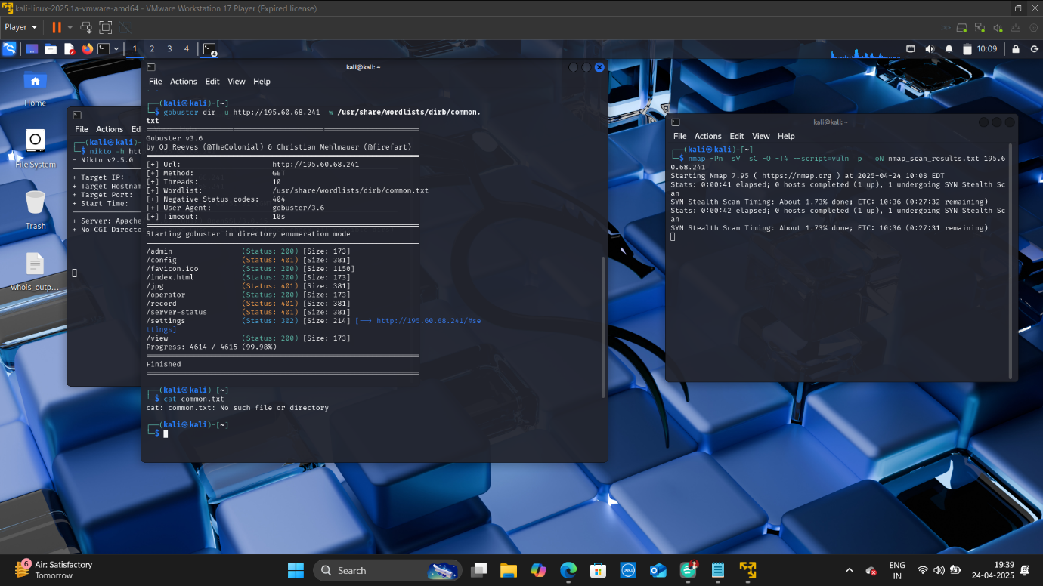

* This report is generated using **WHATWEB AND CURL TOOL**

To get information which is public disclosure

**Command used :** whatweb <http://195.60.68.241/camera/index.html#/video/installation>

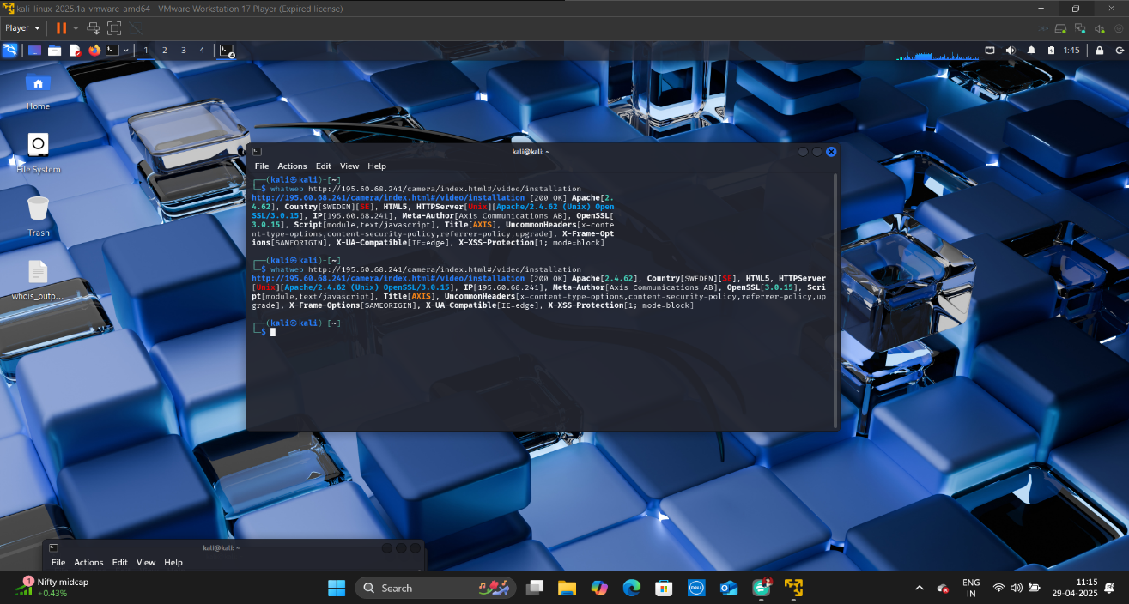

**Command used :** curl -I <http://195.60.68.241/camera/index.html#/video/installation>

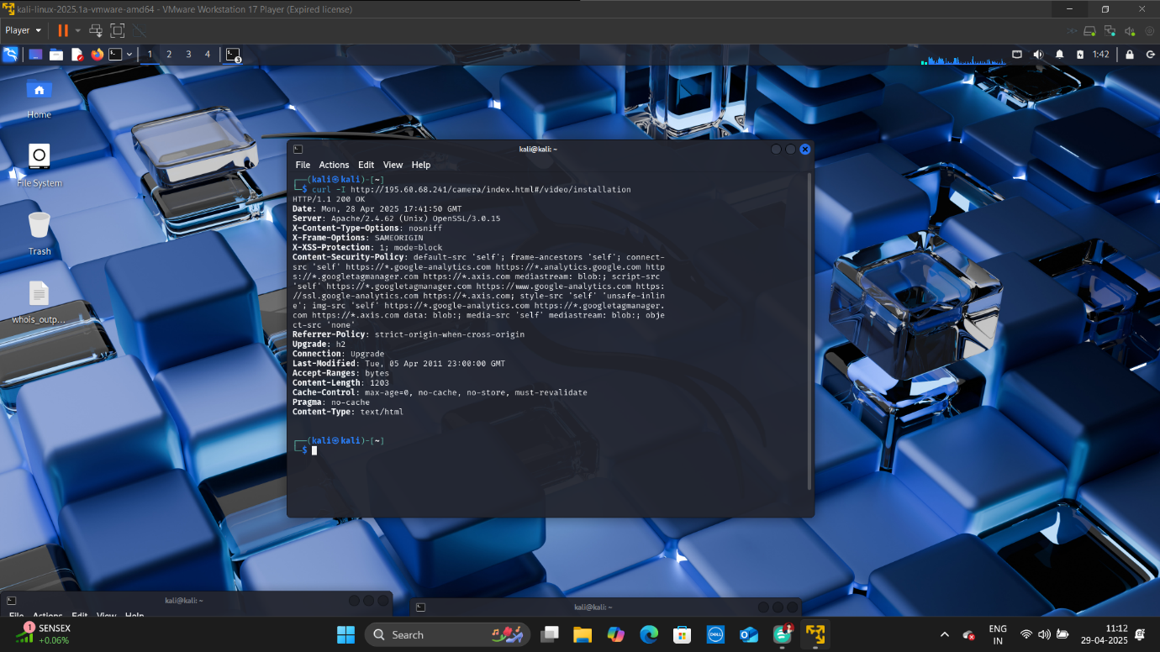

* This report is generated using **NMAP TOOL**

To get the information about Banner grabbing

**Command used:** nmap -sV -- script=banner 195.60.68.241

1. --script=banner: Uses the banner script
   * The banner script is part of Nmap's Scripting Engine (NSE)
   * Specifically designed to grab banners from services
   * Works similarly to connecting to a service manually (like with netcat or telnet)
   * Often reveals useful information like:
     + Service versions
     + Welcome messages
     + System information
     + Sometimes even vulnerability information

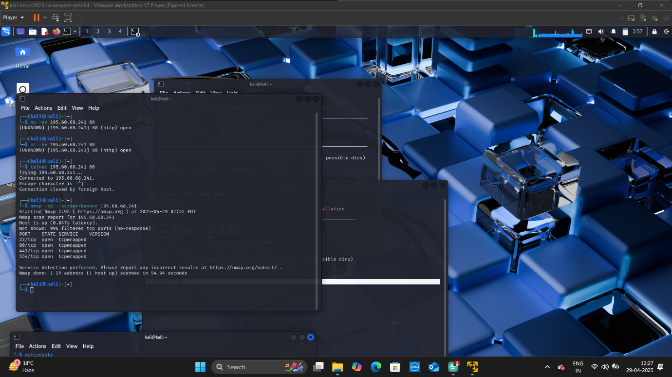

* This report is generated using **NMAP TOOL**

To get information about SSL Certificate

**Command used :** nmap --script ssl-cert -p 443 195.60.68.241

**Command Components Explained:**

1. **nmap**
   * The network scanning tool used for discovery and security auditing.
2. **--script ssl-cert**
   * **SSL Certificate Check**: Runs the ssl-cert Nmap Scripting Engine (NSE) script to extract and analyze the SSL/TLS certificate of the target service.
   * **Key Details Retrieved**:
     + Certificate **subject** (e.g., domain name, organization).
     + **Issuer** (Certificate Authority).
     + **Validity period** (start/expiry dates).
     + **Public key algorithm** (e.g., RSA, ECC).
     + **Signature algorithm** (e.g., SHA256).
     + **SANs** (Subject Alternative Names).
3. **-p 443**
   * Scans only **port 443** (HTTPS/SSL).
   * Without this, Nmap would scan the default top 1,000 ports.
4. **195.60.68.241**
   * The target IP.

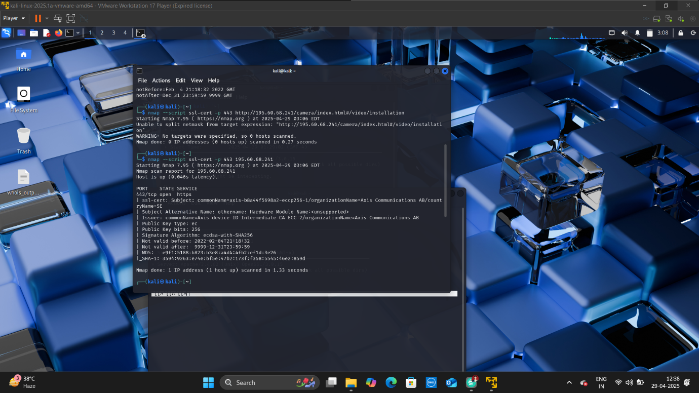

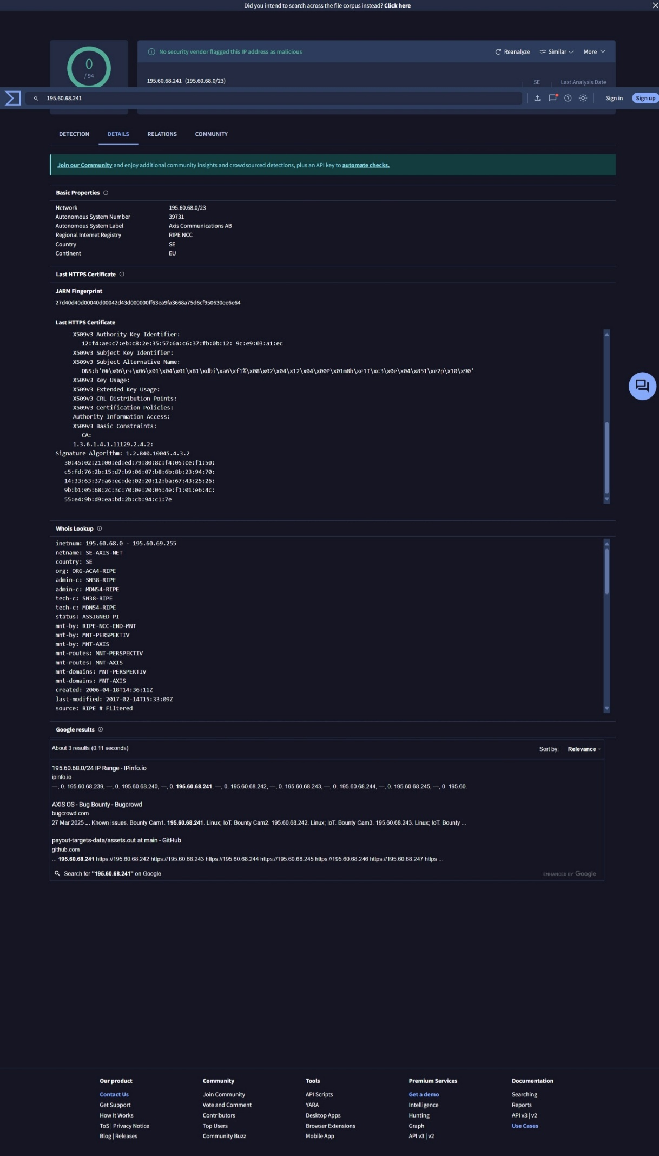

VirusTotal

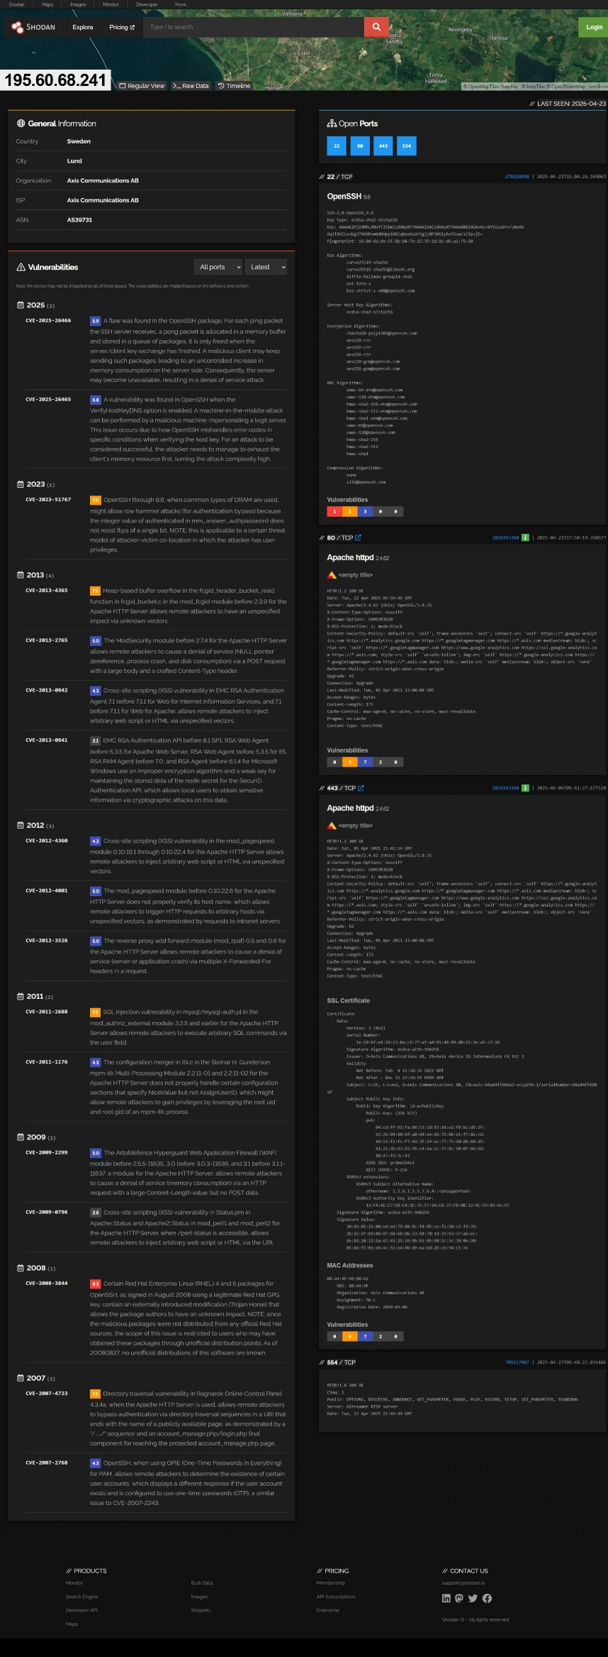

Shodan

REPORT BY

HARSH GOKULPRASAD JAISWAL

INTERNSHIP ID : **KT/CSI/285**